In this project we may need to use the TFT screen library TFT_eSPI to help us to output the result, but just install and define the library can not make our device work, so I make a tutorial in here.

1. Install the TFT_eSPI library, we can do it in the Arduino IDE Sketch> Include Library> Manage Libraries, then type in TFT_eSPI directly and we can find and install it.

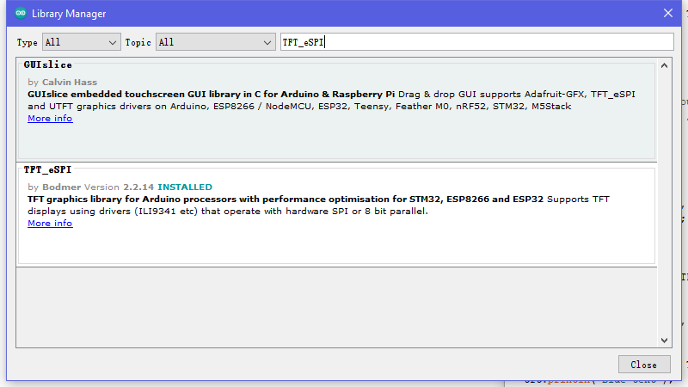

1. Then u will find the library location to edit somethings (the tutorial of how to find the library location is in the group working channel > Evidence > board and screen testing.docx, the default path is C:\Users\admin\Documents\Arduino\libraries).
2. Open it the TFT_eSPI file and open the Use_Setup.h file we need to edit some of the information use, you can use Text pad or other tools such as VS, VS code etc.

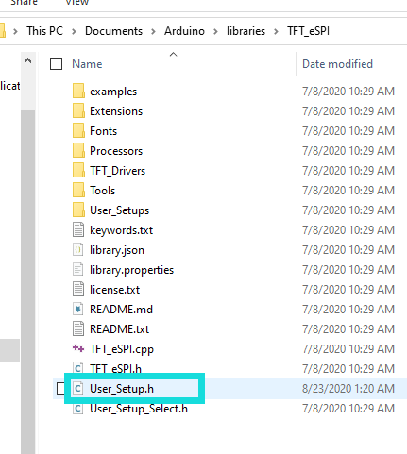

1. You can watch the front half of the video(<https://www.youtube.com/watch?v=rq5yPJbX_uk&t=446s>) and it will teach you how to set up the use of develop board and the screen, but the port number we use will be different(I think it should be the manufacture problem), u can still test the default setting but I think it should not work because I have tested it for several hour. You can follow my testing in here: 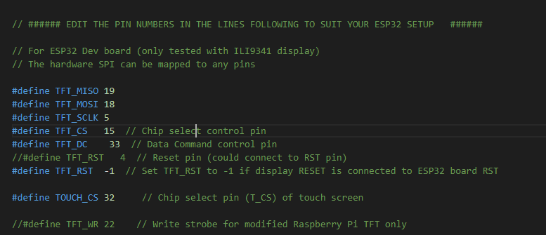

I follow the Github forum to solve the problem(<https://github.com/Bodmer/TFT_eSPI/issues/127>)

